Details of Equipment available at R&D Laboratory

S.  No. | Name of the Equipment | Make | Funded by | Cost (INR) | Date of Installation | Condition
1. | High Content Screening Platform  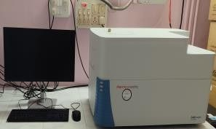 | Thermo Fisher Scientific | DBT | 1,49,00,000 | 31/03/2023 | Working
2. | Bioreactor  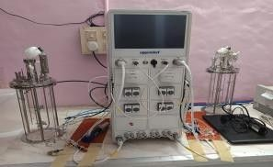 | Eppendorf | DBT | 89,88,252 | 23/12/2022 | Working
3. | Cooling centrifuge  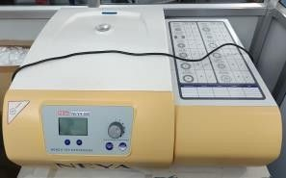 | Remi | ICMR | 4,99,997 | 15/12/2022 | Working
4. | Millipore Filtration Unit  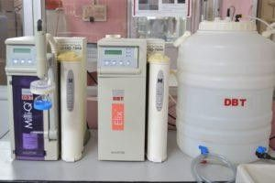 | Millipore | DBT | 9,87,210 | 05/02/2022 | Working
5. | Fluorescence Spectrophotometer  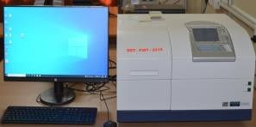 | Hitachi, Japan | DST- FIST | 14,96,250 | 02/03/2022 | Working
6. | Electrochemical Workstation  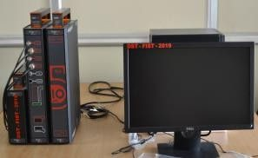 | Origaly’s France | DST- FIST | 14,91,000 | 27/01/2022 | Working
7. | Real-Time PCR  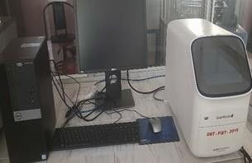 | Applied Bio System | DST- FIST | 19,84,500 | 24/12/2021 | Working

8. | Flow Filtration System  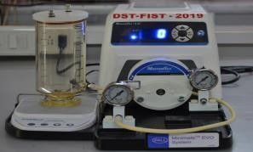 | Pall Minimate EVO System | DST- FIST | 6,98,250 | 23/12/2021 | Working
9. | ELISA reader and washer  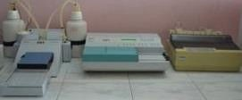 | Thermo Fisher Scientific | DBT | 3,59,900 | 06/06/2020 | Working
10. | Refrigerated Centrifuge  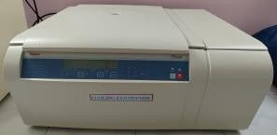 | Thermo Fisher Scientific | DBT | 7,48,710 | 28.02.2020 | Working
11. | Bio-Dot-Dispenser LFIA  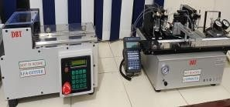 | Biotron Healthcare | DBT | 14,49,467 | 21/03/2019 | Working
12. | Biosafety Cabinet  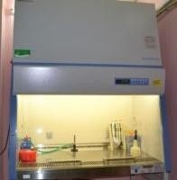 | Thermo Fisher Scientific | DBT | 6,45,802 | 15/12/2017 | Working
13. | Chromatography system (HPLC)  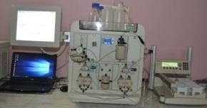 | Bio-Rad | DBT | 29,16,214 | 13/12/2017 | Working
14. | Shaking incubator  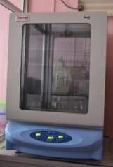 | Thermo Fisher Scientific | DBT | 5,54,604 | 30/11/2017 | Working
15. | Bright Microscope  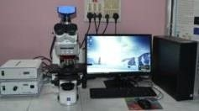 | Carl Zeiss | DBT | 23,65,706 | 08/09/2017 | Working

16. | Aquarium Environmental Control System  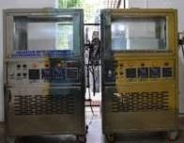 | THE I.L.E. co  Chennai | DBT | 9,97,500 | 18/07/2017 | Working
17. | Image based cytometer  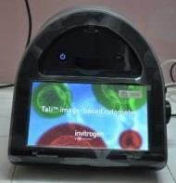 | Thermo Fisher Scientific | DBT | 12,00,000 | 21/06/2017 | Working
18. | 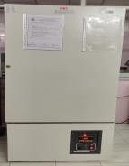  Deep freezer (-20 ̊ C) | Remi Elektrotechnik Ltd | UGC | 83,160 | 17/03/2017 | Working
19. | Freeze dryer  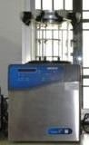 | Labconco, USA | DBT | 9,03,980 | 30/01/2017 | Working
20. | Rotary evaporator  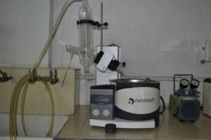 | Inkarp Instruments Pvt. Ltd. | DBT | 2,11,748 | 03/08/2016 | Working
21 | Particle size analyzer  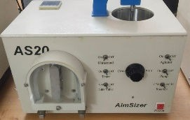 | Aimsizer Scientific Ltd., China | UGC |  | 2015 | Working
22 | Probe ultrasonicater  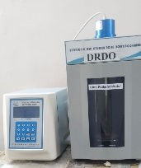 | Aimsizer Scientific Ltd., China | UGC |  | 2015 | Working
23 | Spin coater  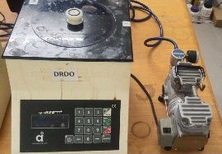 | SPIN NX AGIA | DRDO |  | 2015 | Working

24 | Polishing machine  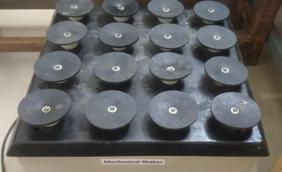 | SSMS Disc Polisher | DRDO |  | 2015 | Working
25. | Lyophilizer  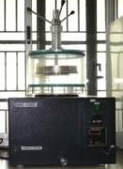 | Southern India Scientific Corporation.  Chennai | UGC | 1,99,374 | 26/12/2013 | Working
26. | Histological Equipment  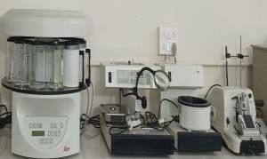 | Leica Microsystems | DBT | 17,28,394 | 24/04/2013 | Working
27. | Gradient PCR  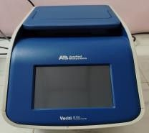 | Applied Bio System | DBT | 2,50,000 | 09/03/2013 | Working
28. | Semi dry blot  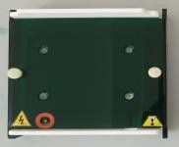 | BioSource & Surgical | DST- FIST | 83,500 | 02/03/2013 | Working
29. | Concentrator Plus  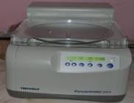 | Eppendorf | DBT | 5,00,000 | 15.07.2012 | Working
30. | Vibra Cell Ultrasonic Processor  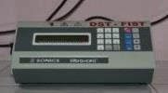 | Mediccare Scientific Supplies | DST- FIST | 2,99,250 | 12.01.2012 | Working
31. | GelDoc system  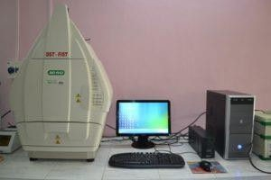 | BioRad | DST- FIST | 7,50,000 | 24.12.2011 | Working
32. | Trans-Blot Turbo Blotting System  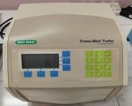 | BioRad | DST- FIST | 2,00,000 | 24.12.2011 | Working

33. | Gene Pulser Xcell Total System  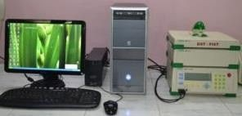 | BioRad | DST- FIST | 2,00,000 | 24.12.2011 | Not working
34. | Nanodrop  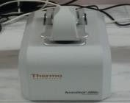 | Nanodrop technologies | DBT | 5,43,818 | 24/03/2010 | Working
35. | 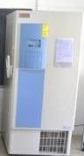  Deep freezer (-80 ̊ C) | Thermo Fisher Scientific | DST | 4,78,097 | 17/06/2009 | Working
36. | UV Visible Spectrophotometer  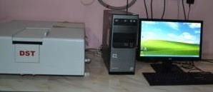 | Shimadzu Asia Pacific Pvt. Ltd. | DST | 5,33,300 | 22/03/2009 | Working
37. | Fermentor  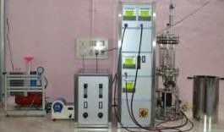 | Bioengineering | DBT | 10,56,000 | 07/10/2008 | Working
38. | Inverted Microscope  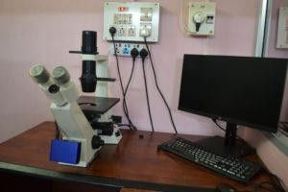 | Carl Zeiss, Germany | DBT | 9,73,162 | 28/02/2008 | Working
39. | Master cycler  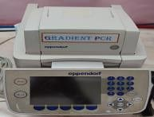 | Eppendorf | ICAR | 4,05,484 | 10/12/2007 | Working
40. | Biophotometer  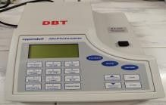 | Eppendorf | DBT | 2,00,000 | 16.04.2007 | Working
41. | Ultracentrifuge  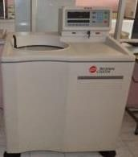 | Beckman Coulter | IFCPAR | 25,00,000 | 20/12/2006 | Working

42. | Freeze Control  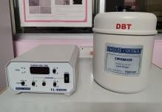 | Cryologic, Australia | DBT | 3,96,520 | 14.11.2006 | Working
43. | CO2 Incubator  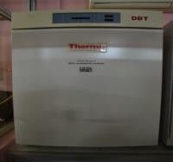 | Thermo Electron Corporation, Hong Kong | DBT | 3,02,806 | 14.11.2006 | Working
44. | Fluorescence Microscope  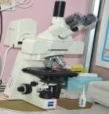 | Carl Zeiss, Germany | ICAR | 3,46,000 | 30/03/2005 | Working
45 | PCR Machine  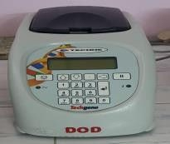 | Technie, UK | MoES | 1,50,000 | 17/02/2003 | Working
45. | Digital camera  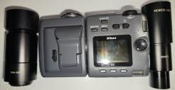 | Ganesh scientific suppliers | ICAR | 61,000 | 23/07/2003 | Working
46. | BOD incubator  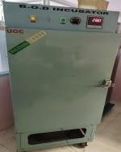 | Thermal Carre | UGC | 50,960 | 18/09/2001 | Working
47. | Laminar Air Flow  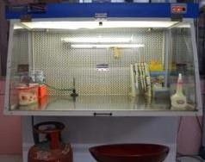 | Clean Air System | UGC | 48,378 | 18/09/2001 | Working

DRDO - Defence Research and Development Organisation DBT - Department of Biotechnology
DST - Department of Science and Technology ICAR - Indian Council of Agricultural Research MoES - Ministry of Earth Sciences
UGC - University Grants Commission
IFCPAR - Indo French Center for Promotion of Advanced Research DST-FIST - DST Fund for Improvement of S&T Infrastructure ICMR - Indian Council of Medical Research

